SafeKit on the AWS Cloud

Quick Start Reference Deployment

March 2019

EVIDIAN

AWS Quick Start team

Visit our [GitHub repository](https://github.com/aws-quickstart/tbd) for source files and to post feedback,   
report bugs, or submit feature ideas for this Quick Start.

Contents

Overview 2

SafeKit on AWS 2

Cost and licenses 3

Architecture 3

Planning the deployment 5

Specialized knowledge 5

AWS account 5

Technical requirements 5

Deployment options 7

Deployment steps 7

Step 1. Sign in to your AWS account 7

Step 2. Subscribe to the SafeKit AMI 7

Step 3. Launch the Quick Start 8

Option 1: Parameters for deploying SafeKit into a new VPC 9

Option 2: Parameters for deploying SafeKit into an existing VPC 10

Step 4. Test the Deployment 12

Best practices for using SafeKit on AWS 12

Security 13

<Other useful information> 13

FAQ 13

Send us feedback 14

Additional resources 14

Document revisions 14

Style Guide 16

Terminology and usage 16

Bullet lists 16

Numbered lists for procedures 16

Tips, notes, and warnings 17

Graphics 17

Tables 18

References 18

Code 18

This Quick Start was created by EVIDIAN in collaboration with Amazon Web Services (AWS).

[Quick Starts](http://aws.amazon.com/quickstart/) are automated reference deployments that use AWS CloudFormation templates to deploy key technologies on AWS, following AWS best practices.

# Overview

This Quick Start reference deployment guide provides step-by-step instructions for deploying SafeKit on the AWS Cloud.

This Quick Start is for users who want to freely try the Evidian SafeKit product for building high availability solutions with real-time replication, load balancing and automatic failover.

## SafeKit on AWS

In a PRIM-SECOND mirror cluster (2 servers),

* the servers are running in different availability zones
* the critical application is running on the PRIM server
* users are connected to a primary/secondary virtual IP address which is configured in the Amazon AWS load balancer
* SafeKit provides a generic health check for the load balancer. On the PRIM server, the health check returns OK to the load balancer and NOK on the SECOND server.
* in each server, SafeKit monitors the critical application with process checkers and custom checkers
* SafeKit restarts automatically the critical application when there is a software failure or a hardware failure thanks to restart scripts
* SafeKit makes synchronous real-time replication of files containing critical data
* a connector for the SafeKit web console is installed in each server. Thus, the high availability cluster can be managed in a very simple way to avoid human errors

In a farm cluster (N servers),

* the servers are running in different availability zones
* the critical application is running in all servers of the farm
* users are connected to a virtual IP address which is configured in the Amazon AWS load balancer
* SafeKit provides a generic health check for the load balancer. When the farm module is stopped in a server, the health check returns NOK to the load balancer which stops the load balancing of requests to the server. The same behavior happens when there is a hardware failure
* in each server, SafeKit monitors the critical application with process checkers and custom checkers
* SafeKit restarts automatically the critical application in a server when there is a software failure thanks to restart scripts
* a connector for the SafeKit web console is installed in each server. Thus, the load balancing cluster can be managed in a very simple way to avoid human errors

## Cost and licenses

You are responsible for the cost of the AWS services used while running this Quick Start reference deployment. There is no additional cost for using the Quick Start.

The AWS CloudFormation template for this Quick Start includes configuration parameters that you can customize. Some of these settings, such as instance type, will affect the cost of deployment. For cost estimates, see the pricing pages for each AWS service you will be using. Prices are subject to change.

**Tip** After you deploy the Quick Start, we recommend that you enable the [AWS Cost and Usage Report](https://docs.aws.amazon.com/awsaccountbilling/latest/aboutv2/billing-reports-gettingstarted-turnonreports.html) to track costs associated with the Quick Start. This report delivers billing metrics to an S3 bucket in your account. It provides cost estimates based on usage throughout each month, and finalizes the data at the end of the month. For more information about the report, see the [AWS documentation](https://docs.aws.amazon.com/awsaccountbilling/latest/aboutv2/billing-reports-costusage.html).

The Evidian SafeKit is deployed with a free trial license key that will stop the product after each 3 days of uptime.

# Architecture

Deploying this Quick Start for a new virtual private cloud (VPC) with **default parameters** builds the following SafeKit environment in the AWS Cloud.

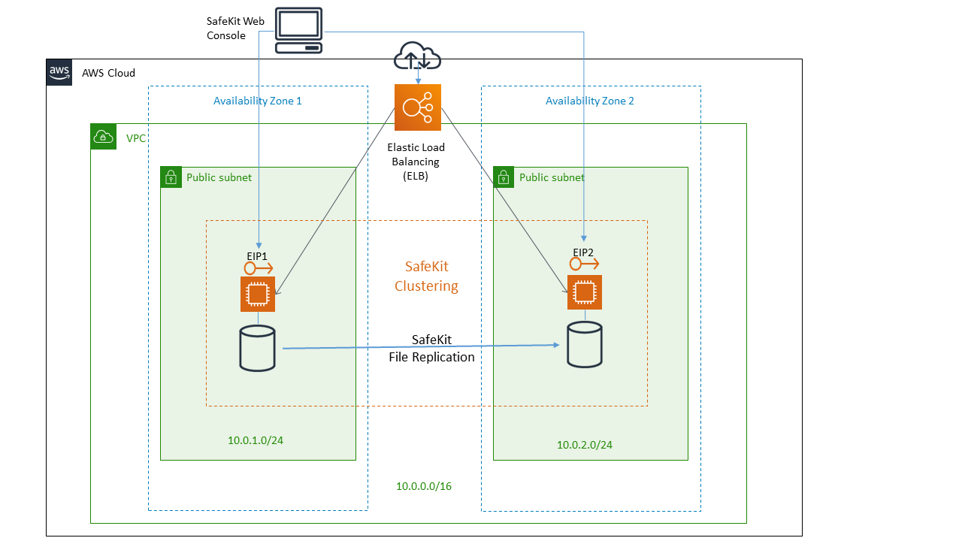

Figure 1: Quick Start architecture for SafeKit mirror on AWS

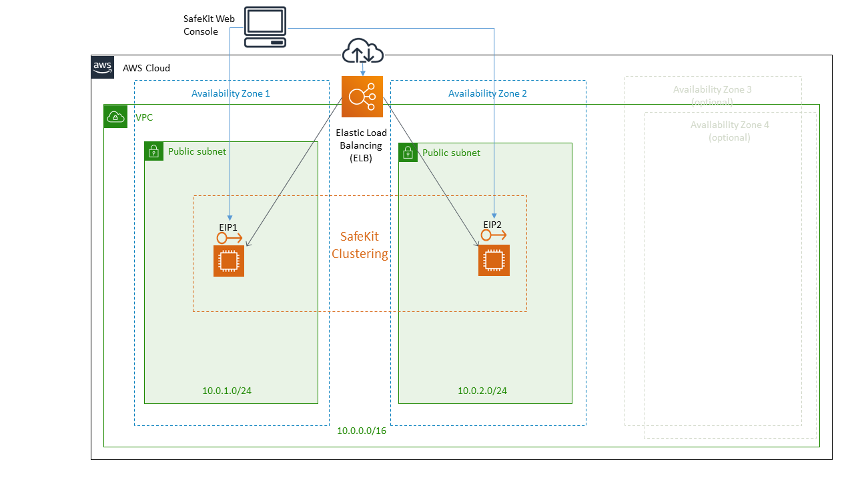

Figure 1: Quick Start architecture for SafeKit farm on AWS

The Quick Start sets up the following:

* A highly available architecture that spans up to four Availability zones (two in case of mirror module).
* One EC2 instance by Availability zone. Instance Images are Linux or Windows 2016.
* A VPC configured with a public subnet by availability zone according to AWS best practices, to provide you with your own virtual network on AWS.
* An Elastic IP by public subnet, for SafeKit web console access.
* A Network Load Balancer with a health check on a URL controlled by SafeKit.
* A Security Group that allow access to port 9453 and to the VIP port to the EIPs.

# Planning the deployment

## Specialized knowledge

This deployment guide requires a moderate level of familiarity with AWS services. If you’re new to AWS, visit the [Getting Started Resource Center](https://aws.amazon.com/getting-started/) and the [AWS Training and Certification website](https://aws.amazon.com/training/) for materials and programs that can help you develop the skills to design, deploy, and operate your infrastructure and applications on the AWS Cloud.

## AWS account

If you don’t already have an AWS account, create one at [https://aws.amazon.com](https://aws.amazon.com/) by following the on-screen instructions. Part of the sign-up process involves receiving a phone call and entering a PIN using the phone keypad.

Your AWS account is automatically signed up for all AWS services. You are charged only for the services you use.

## Technical requirements

Before you launch the Quick Start, your account must be configured as specified in the following table. Otherwise, deployment might fail.

|  |  |  |  |  |  |  |  |  |  |  |  |
| --- | --- | --- | --- | --- | --- | --- | --- | --- | --- | --- | --- |
| [Resources](http://docs.aws.amazon.com/general/latest/gr/aws_service_limits.html) | If necessary, request [service limit increases](https://console.aws.amazon.com/support/home#/case/create?issueType=service-limit-increase&limitType=service-code-) for the following resources. You might need to do this if you already have an existing deployment that uses these resources, and you think you might exceed the default limits with this deployment. For default limits, see the [AWS documentation](https://docs.aws.amazon.com/).  [AWS Trusted Advisor](https://console.aws.amazon.com/trustedadvisor/home?#/category/service-limits) offers a service limits check that displays your usage and limits for some aspects of some services.   |  |  | | --- | --- | | Resource | This deployment uses | | VPCs | 1 | | Elastic IP addresses | 2 to 4 | | Network Load Balancers | 1 | | T2 instances | 2 to 4 | |
| [Regions](https://aws.amazon.com/about-aws/global-infrastructure/) | This deployment includes <service>, which isn’t currently supported in all AWS Regions. For a current list of supported regions, see [AWS Regions and Endpoints](https://docs.aws.amazon.com/general/latest/gr/rande.html#elasticfilesystem-region) in the AWS documentation. |
| [Key pair](https://docs.aws.amazon.com/AWSEC2/latest/UserGuide/ec2-key-pairs.html) | Make sure that at least one Amazon EC2 key pair exists in your AWS account in the region where you are planning to deploy the Quick Start. Make note of the key pair name. You’ll be prompted for this information during deployment. To create a key pair, follow the [instructions in the AWS documentation](https://docs.aws.amazon.com/AWSEC2/latest/UserGuide/ec2-key-pairs.html).  If you’re deploying the Quick Start for testing or proof-of-concept purposes, we recommend that you create a new key pair instead of specifying a key pair that’s already being used by a production instance. |
| [IAM permissions](https://docs.aws.amazon.com/IAM/latest/UserGuide/access_policies_job-functions.html) | To deploy the Quick Start, you must log in to the AWS Management Console with IAM permissions for the resources and actions the templates will deploy. The *AdministratorAccess* managed policy within IAM provides sufficient permissions, although your organization may choose to use a custom policy with more restrictions. |
| [S3 buckets](http://docs.aws.amazon.com/AWSCloudFormation/latest/UserGuide/aws-properties-s3-bucket.html) | Unique S3 bucket names are automatically generated based on the account number and region. If you delete a stack, **the logging buckets are not deleted** (to support security review). If you plan to re-deploy this Quick Start in the same region, you must first manually delete the S3 buckets that were created during the previous deployment; **otherwise, the re-deployment will fail**. |

## Deployment options

* Deploy Evidian SafeKit into a new VPC with a mirror module running. This option builds a new AWS environment consisting of the VPC, subnets, security groups, load balancer, instances and other infrastructure components, then deploys SafeKit into this new VPC and finally install, configure and start a SafeKit mirror module.
* Deploy Evidian SafeKit into a new VPC with a farm module running. This option builds a new AWS environment consisting of the VPC, subnets, security groups, load balancer, instances and other infrastructure components, then deploys SafeKit into this new VPC and finally install, configure and start a SafeKit farm module.

The Quick Start provides separate templates for these options. It also lets you configure instance types, and SafeKit settings, as discussed later in this guide.

# Deployment steps

## Step 1. Sign in to your AWS account

1. Sign in to your AWS account at <https://aws.amazon.com> with an IAM user role that has the necessary permissions. For details, see Planning the deployment earlier in this guide.
2. Make sure that your AWS account is configured correctly, as discussed in the Technical requirements section.

## Step 2. Subscribe to the SafeKit AMI

This Quick Start requires a subscription to the AMI for SafeKit in AWS Marketplace.

1. Sign in to your AWS account.
2. Open the page for the SafeKit AMI in AWS Marketplace, and then choose **Continue to Subscribe**.
3. Review the terms and conditions for software usage, and then choose **Accept Terms**.

You will get a confirmation page, and an email confirmation will be sent to the account owner. For detailed subscription instructions, see the [AWS Marketplace documentation](https://aws.amazon.com/marketplace/help/200799470).

1. When the subscription process is complete, exit out of AWS Marketplace without further action. **Do not** provision the software from AWS Marketplace—the Quick Start will deploy the AMI for you.

## Step 3. Launch the Quick Start

**Notes** The instructions in this section reflect the older version of the AWS CloudFormation console. If you’re using the redesigned console, some of the user interface elements might be different.

You are responsible for the cost of the AWS services used while running this Quick Start reference deployment. There is no additional cost for using this Quick Start. For full details, see the pricing pages for each AWS service you will be using in this Quick Start. Prices are subject to change.

1. Sign in to your AWS account, and choose one of the following options to launch the AWS CloudFormation template. For help choosing an option, see deployment options earlier in this guide.

|  |  |
| --- | --- |
|  |  |
| Deploy SafeKit Mirror into a  new VPC on AWS | Deploy SafeKit Farm into a  new VPC on AWS |

Each deployment takes about ½ hours to complete.

1. Check the region that’s displayed in the upper-right corner of the navigation bar, and change it if necessary. This is where the network infrastructure for SafeKit will be built. The template is launched in the US East (Ohio) Region by default.
2. On the **Select Template** page, keep the default setting for the template URL, and then choose **Next**.
3. On the **Specify Details** page, change the stack name if needed. Review the parameters for the template. Provide values for the parameters that require input. For all other parameters, review the default settings and customize them as necessary.

In the following tables, parameters are listed by category and described separately for the two deployment options:

* Parameters for deploying SafeKit Mirror into a new VPC
* Parameters for deploying SafeKit Farm into a new VPC

When you finish reviewing and customizing the parameters, choose **Next**.

### Option 1: Parameters for deploying SafeKit Mirror into a new VPC

[View template](https://s3.amazonaws.com/quickstart-reference/)

*Network configuration:*

|  |  |  |
| --- | --- | --- |
| Parameter label (name) | Default | Description |
| Availability Zones (AvailabilityZones) | *Requires input* | The list of Availability Zones to use for the subnets in the VPC. The Quick Start uses two Availability Zones from your list and preserves the logical order you specify. |
| Remote Access CIDR (RemoteAccessCIDR) | *Requires input* | The CIDR IP range that is permitted to access the SafeKit Web admin console. We recommend that you set this value to a trusted IP range. For example, you might want to grant only your corporate network access to the software. |
| VIP CIDR (VipCIDR) | 0.0.0.0/0 | The CIDR IP range that is permitted to access the SafeKit virtual IP. We recommend that you set this value to a trusted IP range. |

*Amazon EC2 Instanes configuration:*

|  |  |  |
| --- | --- | --- |
| Parameter label (name) | Default | Description |
| Key pair name (KeyPairName) | *Requires input* | A public/private key pair, which allows you to connect securely to your instance after it launches. This is the key pair you created in your preferred region; see the Technical requirements section. |
| Instance Type (InstanceType) | t2.micro | The type of instances created. |
| OS Type (OSType) | Linux *or*  Windows | The operating system used by instances |

*Evidian SafeKit – Mirror Cluster Configuration:*

|  |  |  |
| --- | --- | --- |
| Parameter label (name) | Default | Description |
| SafeKit module name (SafekitModuleName) | mirror | The name of the SafeKit mirror module that will be configurated. |
| Instance Name Prefix (InstanceNamePrefix) | Server | Server name prefix displayed in the SafeKit web console for each instance. |
| VIP Port (VipPort) | 9453 | The IP port used to access the application via the SafeKit Virtual IP. |
| CA server password (CAservPwd) | *Requires input* | The password that will be asked by the CA server to build client certificates needed to access the SafeKit Web admin console. |

*AWS Quick Start configuration:*

|  |  |  |
| --- | --- | --- |
| Parameter label (name) | Default | Description |
| Quick Start S3 bucket name (QSS3BucketName) | aws-quickstart | The S3 bucket you created for your copy of Quick Start assets, if you decide to customize or extend the Quick Start for your own use. The bucket name can include numbers, lowercase letters, uppercase letters, and hyphens, but should not start or end with a hyphen. |
| Quick Start S3 key prefix (QSS3KeyPrefix) | Quickstart-evidian-safekit/ | The [S3 key name prefix](https://docs.aws.amazon.com/AmazonS3/latest/dev/UsingMetadata.html) used to simulate a folder for your copy of Quick Start assets, if you decide to customize or extend the Quick Start for your own use. This prefix can include numbers, lowercase letters, uppercase letters, hyphens, and forward slashes. |

### Option 2: Parameters for deploying SafeKit Farm into a new VPC

[View template](https://s3.amazonaws.com/quickstart-reference/)

*Network configuration:*

|  |  |  |
| --- | --- | --- |
| Parameter label (name) | Default | Description |
| Number of Instances (NumberOfInstances) | 2 | The number of instances that will be created (each in a different Availability Zone). |
| Availability Zones (AvailabilityZones) | *Requires input* | The list of Availability Zones to use for the subnets in the VPC. The Quick Start uses “NumberOfInstances” Availability Zones from your list and preserves the logical order you specify. |
| Remote Access CIDR (RemoteAccessCIDR) | *Requires input* | The CIDR IP range that is permitted to access the SafeKit Web admin console. We recommend that you set this value to a trusted IP range. For example, you might want to grant only your corporate network access to the software. |
| VIP CIDR (VipCIDR) | 0.0.0.0/0 | The CIDR IP range that is permitted to access the SafeKit virtual IP. We recommend that you set this value to a trusted IP range. |

*Amazon EC2 Instanes configuration:*

|  |  |  |
| --- | --- | --- |
| Parameter label (name) | Default | Description |
| Key pair name (KeyPairName) | *Requires input* | A public/private key pair, which allows you to connect securely to your instance after it launches. This is the key pair you created in your preferred region; see the Technical requirements section. |
| Instance Type (InstanceType) | t2.micro | The type of instances created. |
| OS Type (OSType) | Linux *or*  Windows | The operating system used by instances |

*Evidian SafeKit – Mirror Cluster Configuration:*

|  |  |  |
| --- | --- | --- |
| Parameter label (name) | Default | Description |
| SafeKit module name (SafekitModuleName) | farm | The name of the SafeKit mirror module that will be configurated. |
| Instance Name Prefix (InstanceNamePrefix) | Server | Server name prefix displayed in the SafeKit web console for each instance. |
| VIP Port (VipPort) | 9453 | The IP port used to access the application via the SafeKit Virtual IP. |
| CA server password (CAservPwd) | *Requires input* | The password that will be asked by the CA server to build client certificates needed to access the SafeKit Web admin console. |

*AWS Quick Start configuration:*

|  |  |  |
| --- | --- | --- |
| Parameter label (name) | Default | Description |
| Quick Start S3 bucket name (QSS3BucketName) | aws-quickstart | The S3 bucket you created for your copy of Quick Start assets, if you decide to customize or extend the Quick Start for your own use. The bucket name can include numbers, lowercase letters, uppercase letters, and hyphens, but should not start or end with a hyphen. |
| Quick Start S3 key prefix (QSS3KeyPrefix) | Quickstart-evidian-safekit/ | The [S3 key name prefix](https://docs.aws.amazon.com/AmazonS3/latest/dev/UsingMetadata.html) used to simulate a folder for your copy of Quick Start assets, if you decide to customize or extend the Quick Start for your own use. This prefix can include numbers, lowercase letters, uppercase letters, hyphens, and forward slashes. |

1. On the **Options** page, you can [specify tags](https://docs.aws.amazon.com/AWSCloudFormation/latest/UserGuide/aws-properties-resource-tags.html) (key-value pairs) for resources in your stack and [set advanced options](https://docs.aws.amazon.com/AWSCloudFormation/latest/UserGuide/cfn-console-add-tags.html). When you’re done, choose **Next**.
2. On the **Review** page, review and confirm the template settings. Under **Capabilities**, select the two check boxes to acknowledge that the template will create IAM resources and that it might require the capability to auto-expand macros.
3. Choose **Create** to deploy the stack.
4. Monitor the status of the stack. When the status is **CREATE_COMPLETE**, the SafeKit cluster is ready.
5. Use the URLs displayed in the **Outputs** tab for the stack to view the resources that were created.

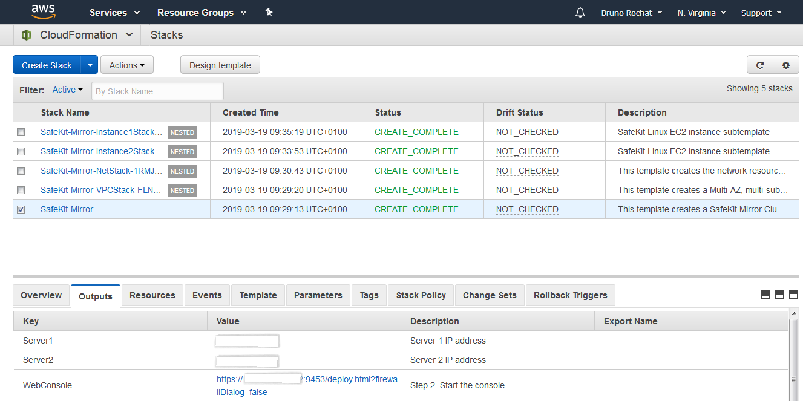

Figure 2: SafeKit mirror outputs after successful deployment

## Step 4. Test the Deployment

After deployment, go to the output panel and

* visit the credential URL to install the client and CA certificates in your web browser. Force the load of the unsafe page. Put as user 'CA_admin' and the password you enter during the template configuration. **Be careful, put the CA certificate in the 'Trusted Root Certification Authority' store (It’s not the default choice).**
* after certificates installation, start the safekit web console.
* for a mirror module, test the primary/secondary virtual IP address with the test URL in the template output. A primary/secondary load balancing rule has been set for external port 9453, internal port 9453. The URL returns the name of the PRIM or ALONE server
* for a farm module, test the load balanced virtual IP address with the test URL in the template output. A load balancing rule has been set for external port 9453, internal port 9453. A mosaic of server names is displayed according the server answering to the TCP session

# Best practices for using SafeKit on AWS

The AWS / SafeKit mirror and farm templates deploy a generic mirror and farm module. These generic modules must be customized to start/stop a critical application, monitor the application with checkers, replicate the critical application folders…

Examples of Windows and Linux modules for applications like Microsoft SQL Server, Oracle, MySQL, PostgreSQL, Firebird, Apache, IIS (etc) are given in the following article: <https://www.evidian.com/products/high-availability-software-for-application-clustering/cluster-configuration/>

The difference between deployment on premises and AWS cloud is on the virtual address management. The virtual IP address in AWS Cloud is implemented thanks to a load balancer. No virtual IP must be configured inside modules when deploying on AWS Cloud.

# Security

For security reasons, only users with an access right can manage the clusters. For that, SafeKit implements certificates that must be installed in the user’s browser. Certificates are installed during the post deployment of the template.

# FAQ

**Q.** I encountered a CREATE_FAILED error when I launched the Quick Start.

**A.** If AWS CloudFormation fails to create the stack, we recommend that you relaunch the template with **Rollback on failure** set to **No**. (This setting is under **Advanced** in the AWS CloudFormation console, **Options** page.) With this setting, the stack’s state will be retained and the instance will be left running, so you can troubleshoot the issue. (For Windows, look at the log files in %ProgramFiles%\Amazon\EC2ConfigService and C:\cfn\log.)

**Important** When you set **Rollback on failure** to **No**, you will continue to incur AWS charges for this stack. Please make sure to delete the stack when you finish troubleshooting.

For additional information, see [Troubleshooting AWS CloudFormation](https://docs.aws.amazon.com/AWSCloudFormation/latest/UserGuide/troubleshooting.html) on the AWS website.

**Q.** I encountered a size limitation error when I deployed the AWS CloudFormation templates.

**A.** We recommend that you launch the Quick Start templates from the links in this guide or from another S3 bucket. If you deploy the templates from a local copy on your computer or from a non-S3 location, you might encounter template size limitations when you create the stack. For more information about AWS CloudFormation limits, see the [AWS documentation](http://docs.aws.amazon.com/AWSCloudFormation/latest/UserGuide/cloudformation-limits.html).

**Q.** Do you have a video demonstrating the AWS / Evidian SafeKit mirror cluster deployment?

**A.** See here: <https://www.evidian.com/products/high-availability-software-for-application-clustering/aws-high-availability-cluster-synchronous-replication-failover/#video_template>

**Q.** Do you have a video demonstrating the AWS / Evidian SafeKit farm cluster deployment?

**A.** See here: <https://www.evidian.com/products/high-availability-software-for-application-clustering/aws-load-balancing-cluster-failover/#video_template>

**Q.** How can I install an Evidian SafeKit mirror cluster on existing AWS servers?

**A.** See here: <https://www.evidian.com/products/high-availability-software-for-application-clustering/aws-high-availability-cluster-synchronous-replication-failover/#step3>

**Q.** How can I install an Evidian SafeKit farm cluster on existing AWS servers?

**A.** See here: <https://www.evidian.com/products/high-availability-software-for-application-clustering/aws-load-balancing-cluster-failover/#step3>

# Send us feedback

To post feedback, submit feature ideas, or report bugs, use the **Issues** section of the [GitHub repository](https://github.com/aws-quickstart/tbd) for this Quick Start. If you’d like to submit code, please review the [Quick Start Contributor’s Guide](https://aws-quickstart.github.io/).

# Additional resources

AWS resources

* [Getting Started Resource Center](https://aws.amazon.com/getting-started/)
* [AWS General Reference](https://docs.aws.amazon.com/general/latest/gr/)
* [AWS Glossary](https://docs.aws.amazon.com/general/latest/gr/glos-chap.html)

AWS services

* [AWS CloudFormation](https://docs.aws.amazon.com/cloudformation/)
* [Amazon EBS](https://docs.aws.amazon.com/AWSEC2/latest/UserGuide/AmazonEBS.html)
* [Amazon EC2](https://docs.aws.amazon.com/ec2/)
* [IAM](https://docs.aws.amazon.com/iam/)
* [Amazon VPC](https://docs.aws.amazon.com/vpc/)

SafeKit documentation

* Amazon AWS / Evidian SafeKit Mirror Cluster Template   
  <https://www.evidian.com/products/high-availability-software-for-application-clustering/aws-high-availability-cluster-synchronous-replication-failover/>
* Amazon AWS / Evidian SafeKit Farm Cluster  
  <https://www.evidian.com/products/high-availability-software-for-application-clustering/aws-load-balancing-cluster-failover/>
* Evidian SafeKit  
  <https://www.evidian.com/products/high-availability-software-for-application-clustering/>

Other Quick Start reference deployments

* [AWS Quick Start home page](https://aws.amazon.com/quickstart/)

# Document revisions

|  |  |  |
| --- | --- | --- |
| Date | Change | In sections |
| March 2019 | Initial publication | — |

© 2019, Amazon Web Services, Inc. or its affiliates, and <partner organization>. All rights reserved.

**Notices**

This document is provided for informational purposes only. It represents AWS’s current product offerings and practices as of the date of issue of this document, which are subject to change without notice. Customers are responsible for making their own independent assessment of the information in this document and any use of AWS’s products or services, each of which is provided “as is” without warranty of any kind, whether express or implied. This document does not create any warranties, representations, contractual commitments, conditions or assurances from AWS, its affiliates, suppliers or licensors. The responsibilities and liabilities of AWS to its customers are controlled by AWS agreements, and this document is not part of, nor does it modify, any agreement between AWS and its customers.

The software included with this paper is licensed under the Apache License, Version 2.0 (the "License"). You may not use this file except in compliance with the License. A copy of the License is located at <http://aws.amazon.com/apache2.0/> or in the "license" file accompanying this file. This code is distributed on an "AS IS" BASIS, WITHOUT WARRANTIES OR CONDITIONS OF ANY KIND, either express or implied. See the License for the specific language governing permissions and limitations under the License.

# Style Guide

Delete this section after following these guidelines.

## Terminology and usage

* For a word list and usage guidelines for AWS content, see the [AWS Usage Dictionary](https://alpha-docs-aws.amazon.com/awsstyleguide/latest/styleguide/dictionary.html) (internal AWS use only).
* For AWS service names and allowed variations, see the [AWS Service Names](https://w.amazon.com/bin/view/AWSDocs/editing/service-names/) wiki page (internal AWS use only).

## Bullet lists

* Use the **List Bullet** style instead of using the bullets control on the Word ribbon.
* Use the **List Paragraph** style for additional paragraphs under the bullet.
* Use nested bullet lists sparingly.
* Use the **List Bullet 2** style for second-level bulleted lists.
* Keep both first-level and second-level lists short. Three to seven items is a good rule of thumb to follow.
* Manually change the spacing after the last item to 14 pt.

## Numbered lists for procedures

1. Use a numbered list only when there’s a sequence (of steps, or priorities, etc.) involved. (Note that we’re using a numbered list in this section to illustrate formatting, but this information would require bullets, not numbers.)
2. Use the **List Number** style instead of using the numbered list control on the Word ribbon.
3. Use the **List Paragraph** style for additional paragraphs under the number.
4. Use nested lists sparingly.
5. Use the **List Number 2** style for second-level numbered lists.
6. Manually change the spacing after the last item to 14 pt.

## Tips, notes, and warnings

Use the **Note** style, which provides the following formatting. Change “Note” to “Tip” or “Warning” as needed.

**Note** You are responsible for all costs incurred by your use of the AWS services used while running this Quick Start Reference Deployment. See the pricing pages of the specific AWS services you will be using for full details.

## Graphics

* Use the **Picture** style, which centers the illustration.
* Below the figure, add the figure caption using the **Caption** style. Specify the number in the format **Figure *n*: Caption**. Use sentence capitalization for captions (that is, just capitalize the first word and any proper nouns).
* For architecture diagrams, use our [PowerPoint template](https://github.com/aws-quickstart/quickstart-examples/raw/master/doc/Quick%20Start%20architecture%20diagram.pptx) template and the [AWS simple icons](https://aws.amazon.com/architecture/icons/), and send us the source file.
* For screenshots:
* Use where the UI is confusing or complex. Avoid using screenshots for login screens or any UI that’s self-explanatory.
* Crop screenshots to the smallest useful size, centering on the topic of discussion but showing just enough surrounding area to establish context.
* Blur all personal information.
* Fill in values when displaying settings.
* If capturing a browser screen, try making the window smaller to decrease the width of the image and to minimize the need to resize it.
* Highlight hard-to-find elements with a green arrow or rectangle with no shadows. Or send us the screenshot without highlighting and let us know where we need to add it.
* Provide an explanation in text. Don’t rely on screenshots alone to convey information.
* For detailed guidelines, see [Art](https://alpha-docs-aws.amazon.com/awsstyleguide/latest/styleguide/graphics.html) in the *AWS Style Guide* (internal AWS use only).

## Tables

* Create a table in Word (**Insert** > **Table**), and apply the **AWS** table style from the menu on the **Table Tools**, **Design** tab. There’s also an **AWS wide** style if you need a wider table.
* Use the **Table text** style for the contents of the table.
* Add boldface for headings.
* Turn on the **Repeat Header Rows** option on the **Table Tools**, **Layout** tab.

|  |  |  |  |  |
| --- | --- | --- | --- | --- |
|  | January | February | March | April |
| North | Red | Green | Blue | Black |
| South | Red | Green | Blue | Black |
| East | Red | Green | Blue | Black |
| West | Red | Green | Blue | Black |

## References

* Use the **Hyperlink** style.
* Use the title of the paper or website as link text. Don’t use phrases like “click here” or “this website” for your links.
* In some cases, you might want to shorten the link text and weave it into the sentence, e.g., “Create a [key pair](http://docs.aws.amazon.com/AWSEC2/latest/UserGuide/ec2-key-pairs.html) in your preferred region.”
* Don’t display the URL in text unless you’re linking to a home page or to a main section under the home page.
* When providing information from other sources, be sure to use your own words. Use short quotations if necessary. It’s OK to use text from the AWS documentation.

## Code

For code that appears within a sentence, use the Code Inline style.

For code blocks, use the **Code Snippet** style:

"Conditions": {

"GovCloudCondition": {

"Fn::Equals": [

{

"Ref": "AWS::Region"

},

"us-gov-west-1"

]

}

},

In the HTML version of the deployment guide, we can use syntax highlighting for selected languages, including JSON, PowerShell, Bash, and Python. The PDF format doesn’t support syntax highlighting.